**Image Comparison in python :**

Hello My name is Muhammad Ahmad Humayoun and I am a python developer working on Computer Vision .

This Project is specifically designed for comparing the Images , Highlighting the difference ,Giving threshold , giving the similarity percentage and Giving the heatMaps of them .

**Installations:**

pip install opencv-python scikit-image imutils

and than just run in cmd :

python ./ComparePictures.py

Sample Output will give six windows :

2 Windows of Comparison :

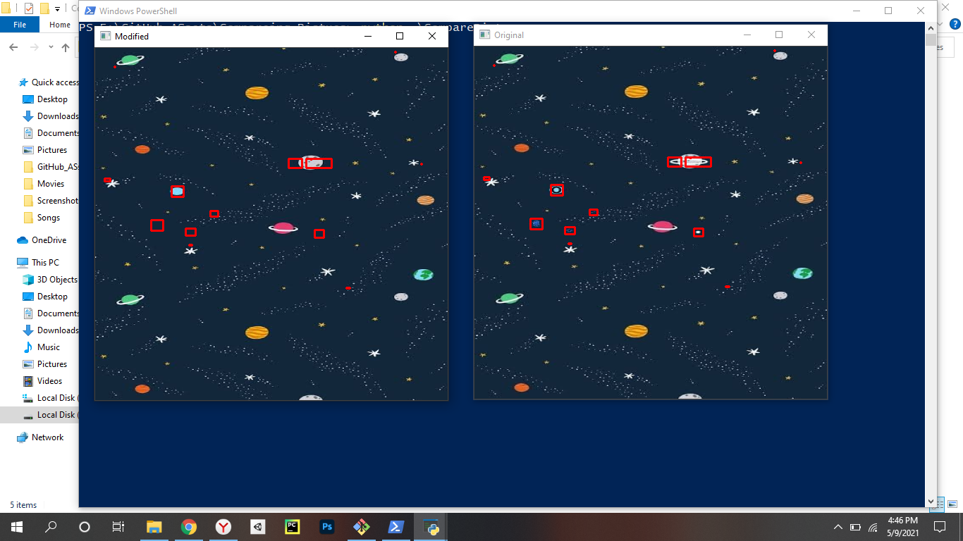

Second two Windows of threshold:

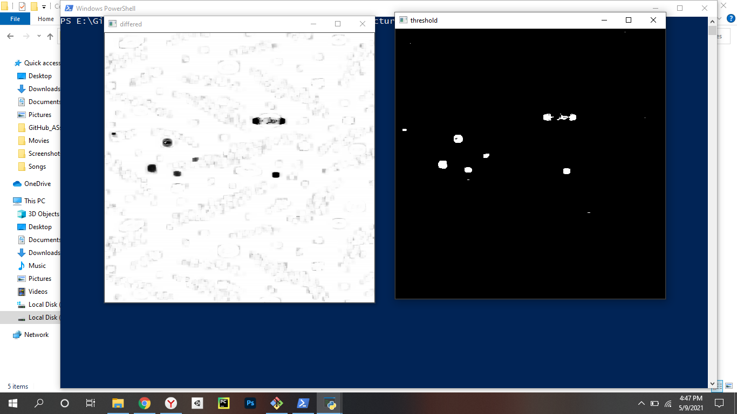

And last 2 Windows of Heat Maps:

